Math 8 Application 11 Name ________________________
Show all your work!

1. Circle the letter that represents the approximate location on the number line of $\sqrt{45}$  A B C D  0 5 10 15 | 2. Simplify without a negative exponent:  4⁻³ = | 3. Solve for x:  X⁴ = 81
4. Write in standard notation.  5.48 ∙ 10⁻⁶ | 5. Write the product in scientific notation.  (1.2 ∙ 10³) (3.7 ∙ 10³) = | 6. Solve for x.  -2x – 15 = x + 13
7. What type of transformation of Figure A resulted in Figure B?  A B | 17. Find the length of side a below.  7 in. a  9 in. | 9. Find the measure of angle b.  51◦  b
10. Put the following numbers in order from smallest to largest.  40%, ¼, 17, .32 | 11. Estimate the product below.  76,210 ∙ 612 = | 12. Write the fraction as a percent. $\frac{7}{25}$
13. Fred made the following pattern with chips. Write an equation that describes Fred’s function. | 14. Graph Fred’s function  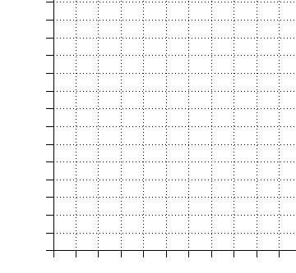 | 15. Complete the table.
   |  | o o
   | o o | o o
  o | o | o
   | o o | o o
   |  | o o
  Stage 1 | Stage 2 | Stage 3
  Stage | Total chips
  1
  2
  3
  5
  10
16. At Julie’s store, if she increases the price of her product by 25% in order to make a profit, what should she sell a product for that cost her $30? | 17. Find the volume of a cone with a diameter of 8 mm and a height of 12 mm. | 18. Sara traveled 425 miles in 5 hours. What was her rate of speed in miles per hour?
19. Juan’s quiz scores are 14, 12, 10, 15, and 15. What is the mean of his quizzes? | 20. Fred bought a pound and a half of ground beef and three quarters of a pound of ground turkey. How many ounces of meat did Fred buy? | Number correct  5 minutes_______  Total___________

